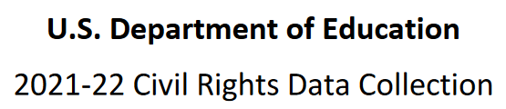

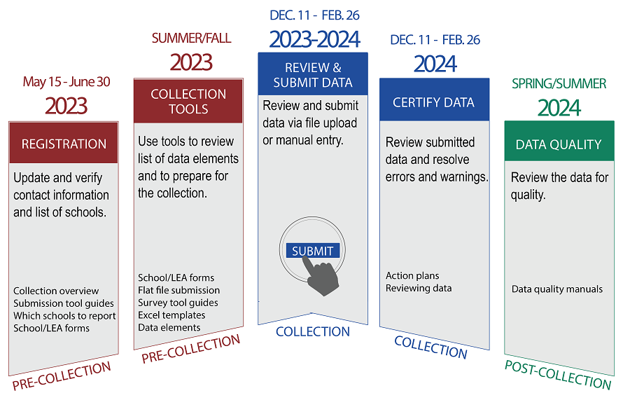

Civil Rights Data Collection (CRDC)

Collection Timeline:
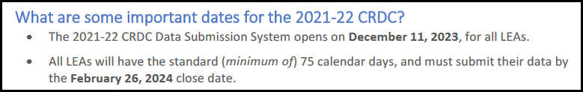
Phase | Opens | Closes
2021 – 2022 Registration | May 15, 2023 | June 20, 2023
2021 – 2022 CRDC Data Submission Due | December 11, 2023 | February 26, 2024

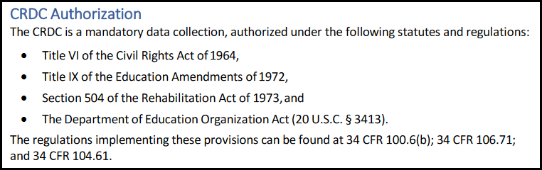

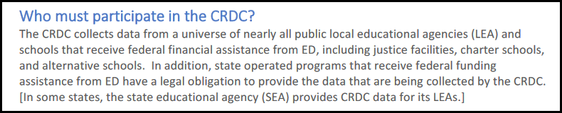

What is the snapshot date for the 2021-22 CRDC?

We suggest you use the 2022 Fall PEIMS As-of-Date of 10-29-2021. This will allow you to check some of your student counts and staff FTEs against your 2022 Fall PEIMS reports.

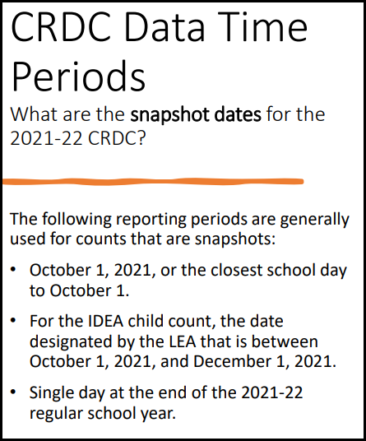

CRDC Resource Center

https://crdc.communities.ed.gov/#program

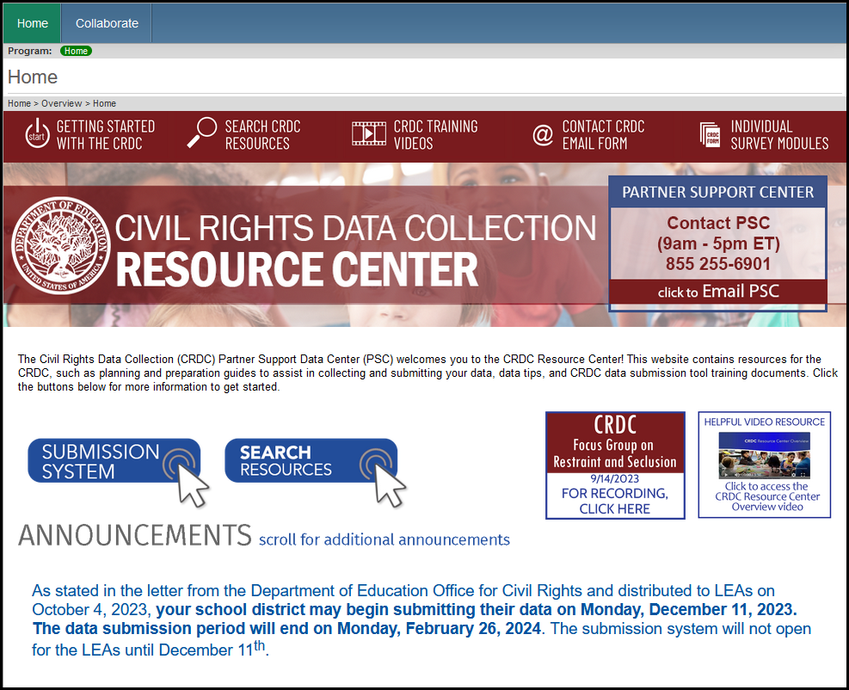

Search Resources



All of the resources on this page will assist you with the OCR Submission. The highlighted documents below are great resources to download and have available.

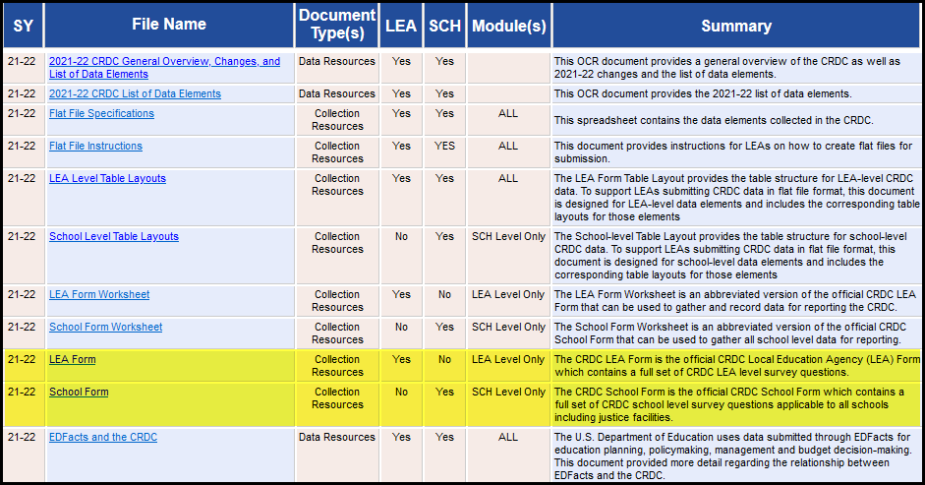

PSC (Partner Support Center) Email Form

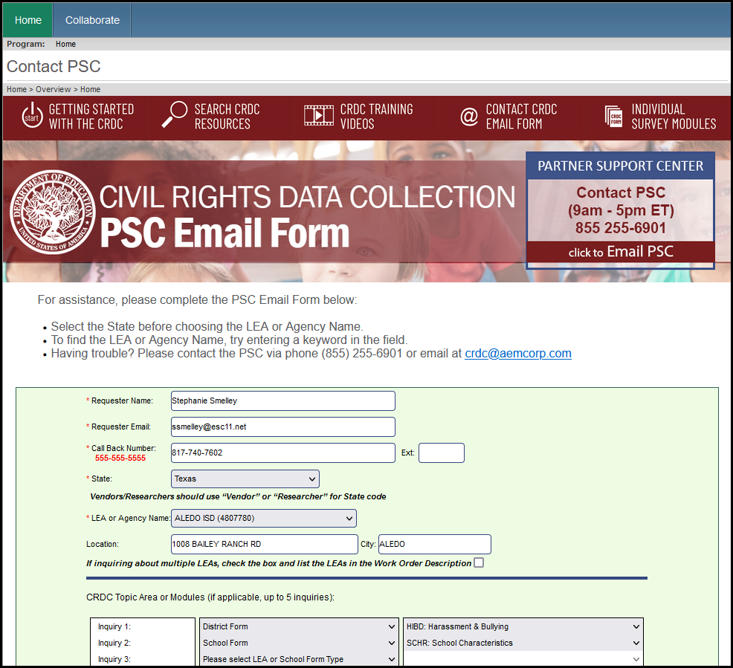

Individual Survey Modules

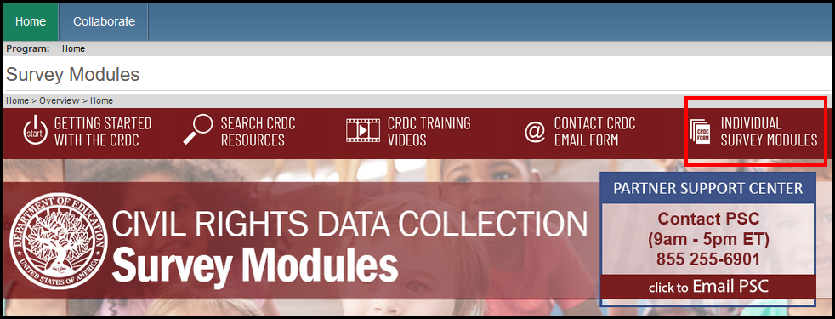
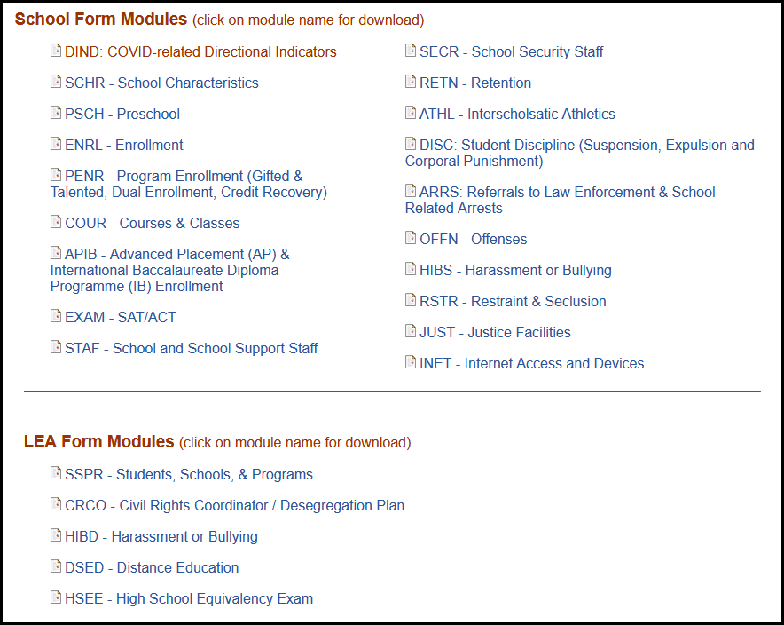

Getting to the CRDC Survey Tool

https://surveys.nces.ed.gov/crdc/
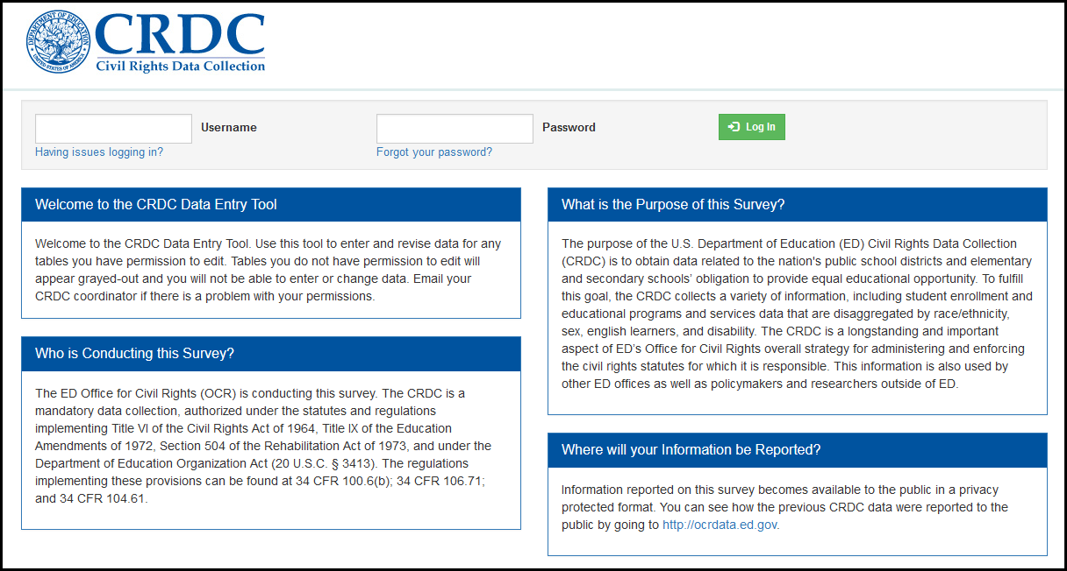
- Once users select the Confirm button to indicate an understanding of this message, they are taken to the Home page itself.

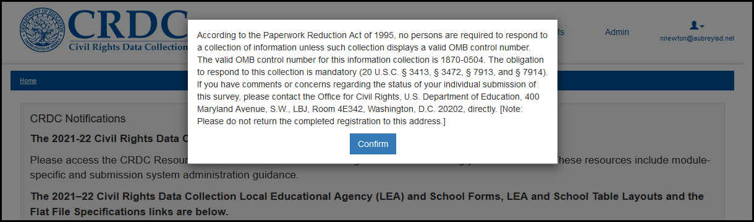

Home Page

The top area of the Home page contains basic information and notifications about the submission process, including contact information for the Partner Support Center (PSC). The PSC helps respondents with their CRDC data submissions.

In the upper-right portion of the screen are menu links to other areas of the tool: Resources and Reports, for all users; and Admin and Certification, only for those users with the appropriate permissions. These areas of the tool and the permissions required to use them are explained in the relevant sections of this guide.

User controls are represented in the menu links by an icon of a person’s head, with the current user’s email address displayed underneath.

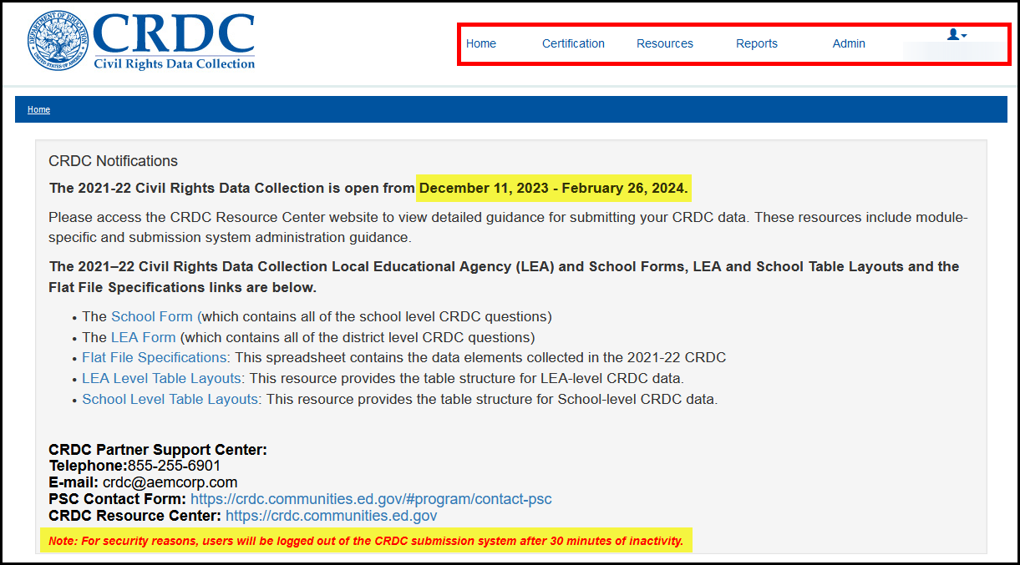
The middle of the page shows the LEA for which data are currently being submitted. As the majority of LEA and school users of this system are only associated with (and only have permission for) one LEA, they will only see their own LEA listed here. Any users possessing permissions for more than one LEA and/or state will see pull-down menus that list multiple states and/or LEAs to choose from.

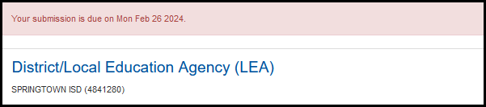

The bottom third of the page presents the two methods for submitting the required data. The Data Entry & Review Tool method involves completing online district and school forms, while the File Upload method involves uploading a prepared flat file.

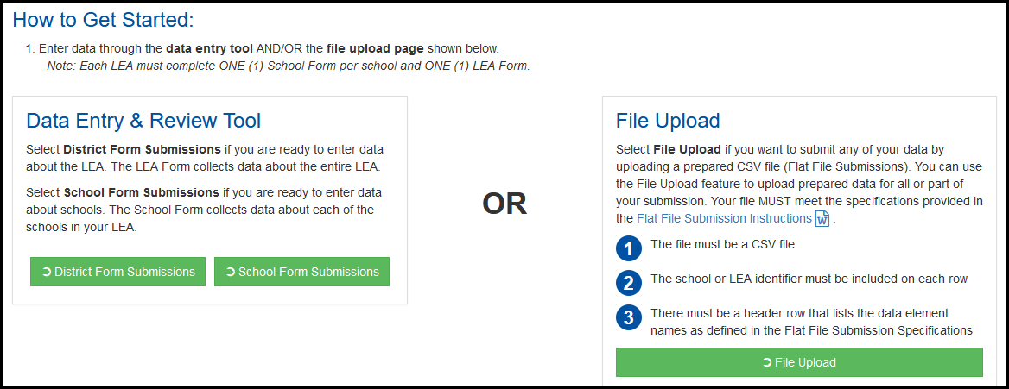

Two methods will be available for Local Education Agencies (LEAs) to report data.

- Online Data Entry: The Online data entry method using the Web interface during the survey open period requires users to hand-key in responses to the CRDC data elements. Using only the Web-based submission method may not be practical for large LEAs that must enter data for a large number of schools.

- Flat File Submission (FFS): The second method is to report data by preparing and uploading one or more text-based flat files in comma-separated value (.csv) format. The FFS method allows an LEA to prepare one or more data files that contain data elements required in the SY 2020-21 CRDC. This method may be used to provide all of the data for the CRDC or a partial set of CRDC data. These files must conform to the FFS formats and specifications included with this document. These files can be uploaded once the survey opens.

LEAs may also choose to combine these two methods. For example, an LEA may choose to use the FFS method for the majority of its CRDC submission, and then allow individual schools to enter data via the online survey tool for a subset of specific questions (e.g., interscholastic athletics).

Admin > User Management (see the 2021-22 CRDC Submission System User Guide)

- Register Users
- Manage User Permissions

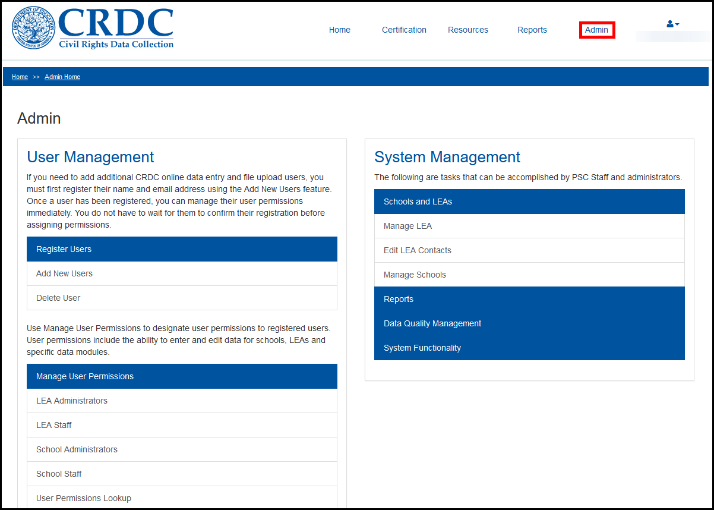

Admin > System Management:

- Manage LEA
- Edit LEA Contacts
- Manage Schools

For Additional Resources:

- Select Resources

Sessions

- Users should NOT have multiple sessions open and active of the CRDC Web Survey Tool at the same time on the same computer. This may cause data corruption.

Session Timeout

- For security reasons, users will be logged out of the CRDC submission after 30 minutes of inactivity.

To Upload Files:

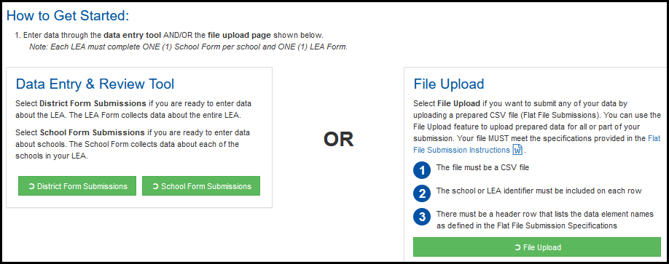

- Select File Upload if you want to submit any of your data by uploading a prepared CSV file (Flat File Submissions). You can use the File Upload feature to upload prepared data for all or part of your submission.
- For more information on upload specifications and loading partial files click on 2021 – 2022 Flat File Specifications link under File Upload.
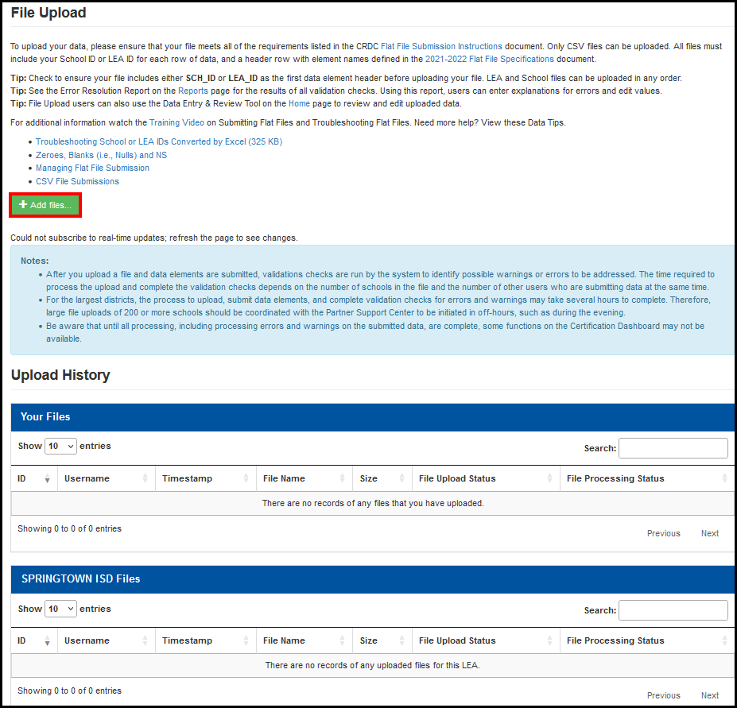
- Click the +Add files button.

- Browse for the files you wish to upload. Upload all files before starting the process.
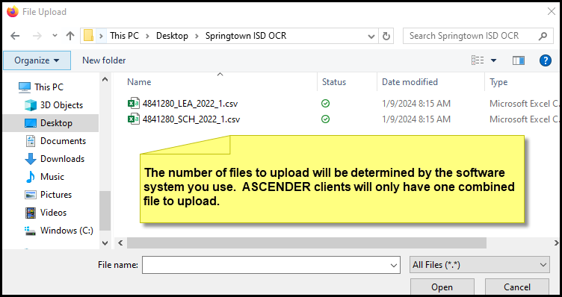

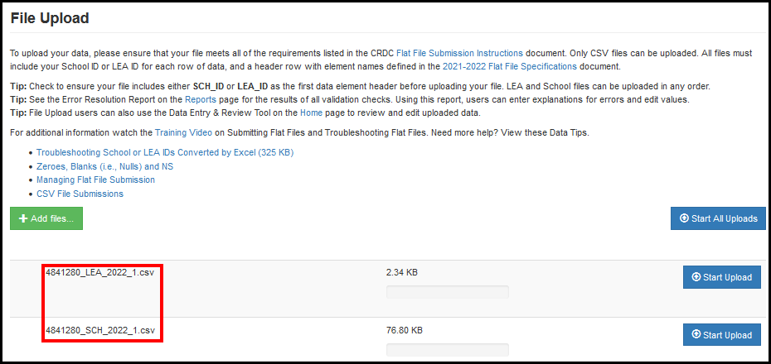
- Once files have been selected and added, the user simply selects the Start Upload button (or, in the case of multiple files, Start All Uploads) to initiate the actual upload. The screen will show the progress of the upload itself in real time, which will likely occur quickly for files of a reasonable size.

You forgot to enter the 5 digit NCES ID Code for a campus or campuses.

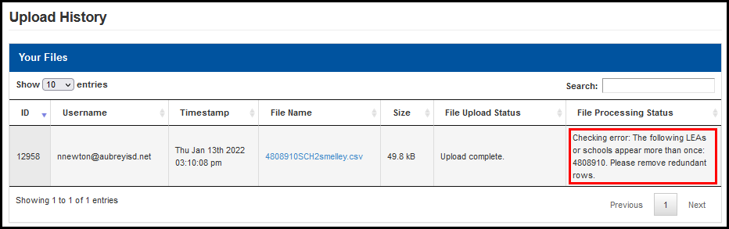

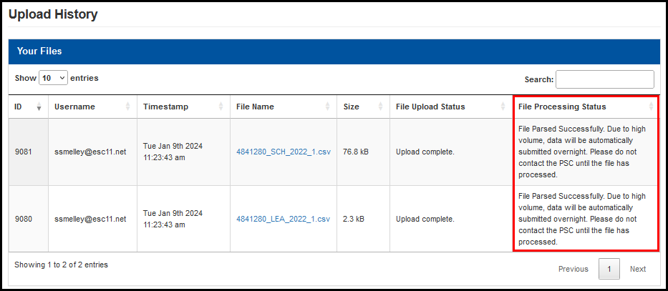

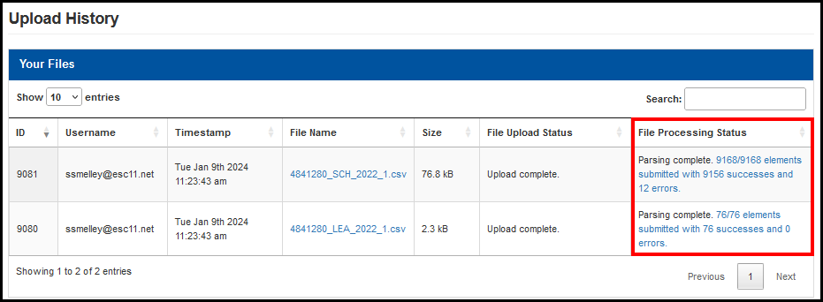

- Once the data has uploaded, issues found may be addressed either by further file uploads with corrected data using the templates or handling of individual issues using the Data Entry portion of the CRDC Survey Tool.
- The data submitted to the CRDC Survey Tool using either the Data Entry or File Upload functionality all go to the same data stores. As such, some data may be reported using one means while other data may be submitted using the other. Each method may be used to correct or address errors arising from the other.

Data Entry & Review Tool

- Select District Form Submissions if you are ready to enter data about the LEA. The LEA Form collects data about the entire LEA.
- Select School Form Submissions if you are ready to enter or review data about schools. The School Form collects data about each of the schools in your LEA.

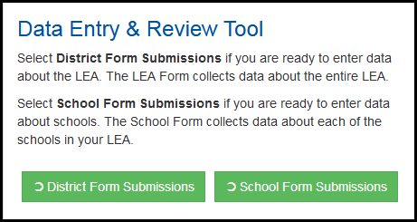

ASCENDER - LEAs will be required to manually update all District Form Submission information.

To Use the District Form Submissions:

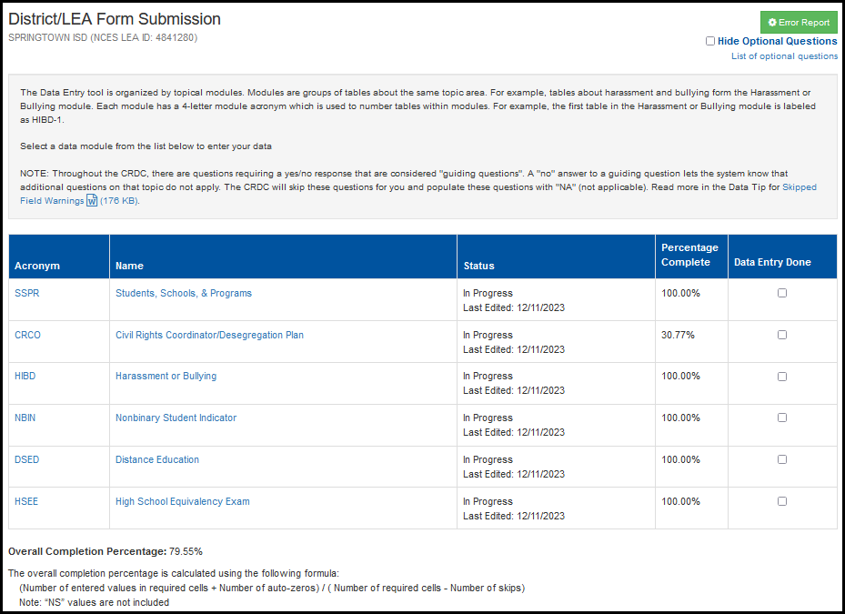
- Click on District Form Submissions

- This is the Table Navigation Module Landing page. Each module that is currently active and open for data entry shows up with its acronym and full name as active links available for selection. Clicking on either the acronym or full name will take a user to the same page.
- Notice the Module Instructions on the right-hand side. This will give you additional information and tips for completing the tables.
- Select a table for data entry or review.

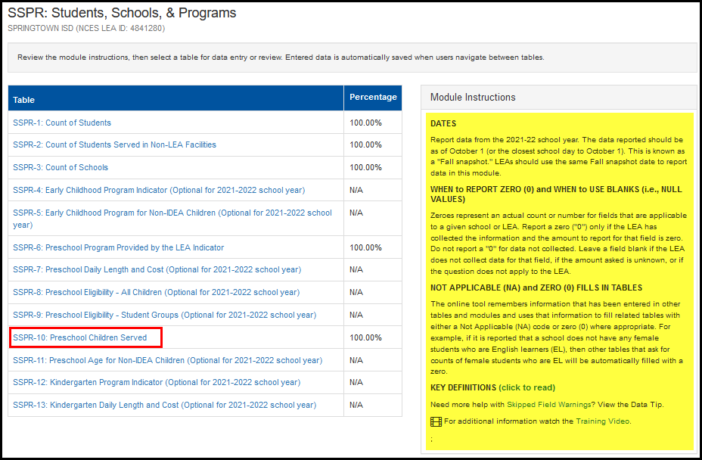
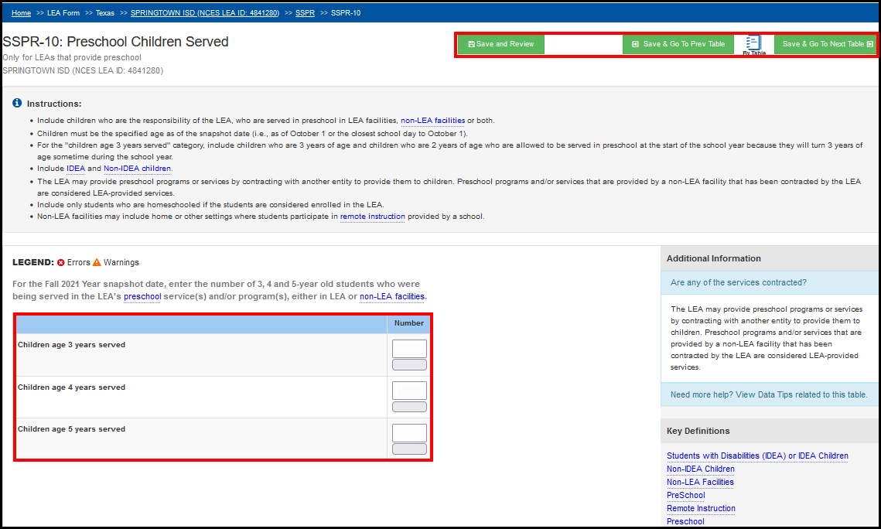
- Enter the required information. Entered data is automatically saved when users navigate between tables. Choose the Save option you wish to use.

To Save & Review:

- Once some or all of the data has been entered for an individual table, the user can select the Save and Review button to apply the business rules to this data. In return, the system will return an Error and Warning Summary for the table as a whole, showing any errors, warnings, and pending validation checks that apply to the data entered.
- The Error and Warning Summary only shows a list of the data elements checked, with a count of Warnings or Errors for each beside it.
- Each of the elements with active errors or warnings may be expanded to give you a detailed list of the specific errors and warnings found for that element.
- Each specific error or warning may be further expanded upon within the summary by clicking on Error.

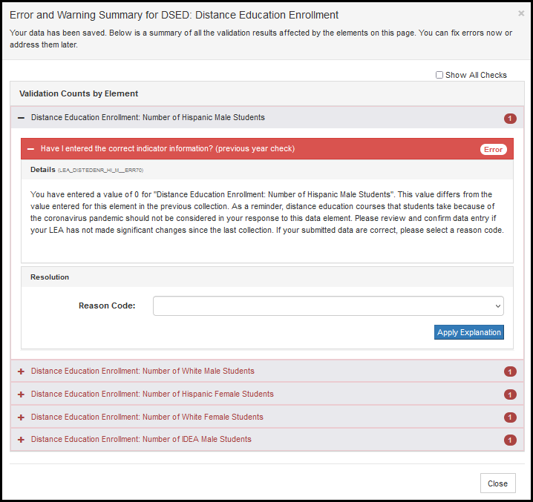

- Depending on the error and the reason code selected, the reason code may be sufficient explanation, or a comment may also be required. The reason code OTH: Other Reason, as a catch-all, will always require further explanation by means of a comment.

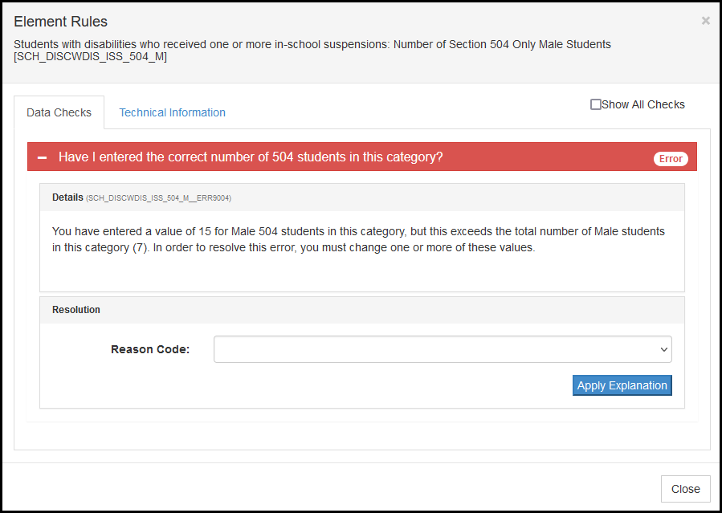
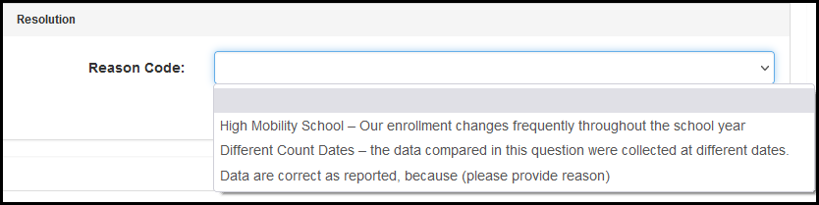

- Once the required information has been selected and filled in, the user may select Apply Explanation in order to submit the explanation.
- If the explanation is accepted, the status of the validation check will change to Error Explained.
- This change in status will then be reflected by there being one less error in the error and warning count on the Save and Review button, in the Error and Warning Summary, and by the validation check icons within the table.

To View Errors:

The Error Report provides a list of data modules for the District or School Form and the number of warnings and errors currently known to exist according to the validation checks.
The user may expand any module in the Error Report in order to see more detail on the specific questions with warnings or errors. Errors are defined as conditions where the data must either be corrected by changing the value in the field or the apparent discrepancy must be explained prior to certification of the district’s data submission. Warnings are defined as conditions where a possible issue has been identified, but a correction or explanation is not necessary prior to certification.

- Click on Data Entry & Review Tool > District Form Submission
- Click on Error Report

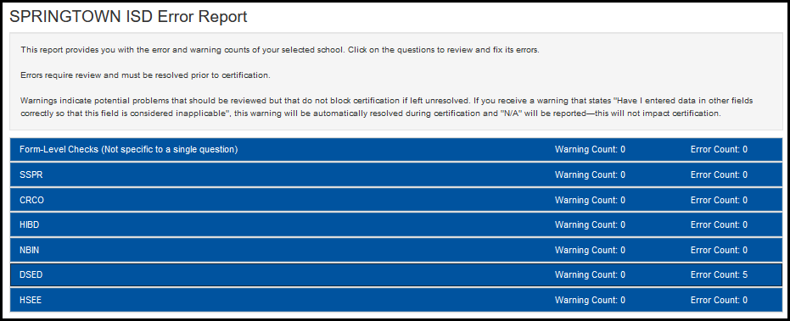
- Click on the Screen Title to view and edit.
- Click on the Question to view and edit.
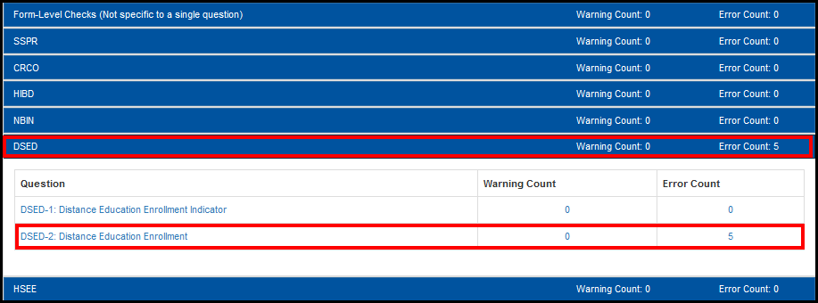

- Click on the Red X

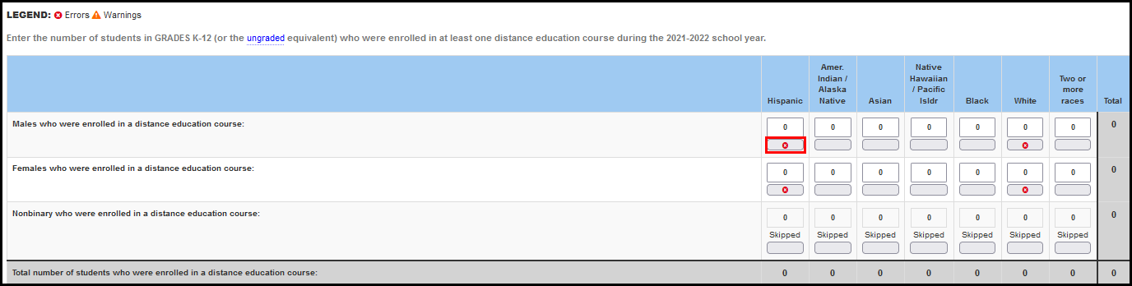

Click the + sign to drill down in the error.

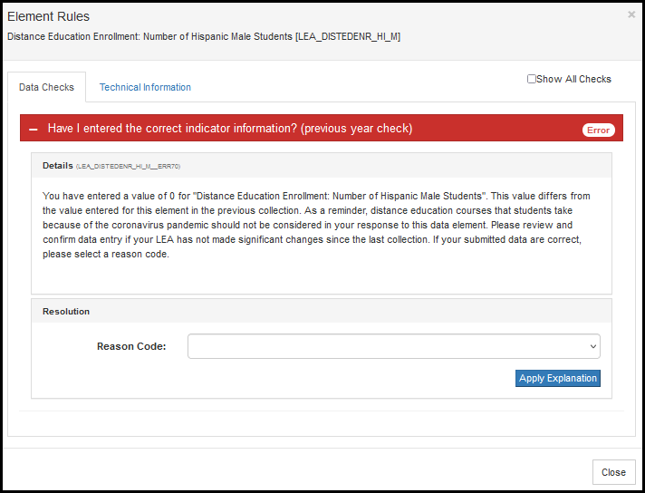

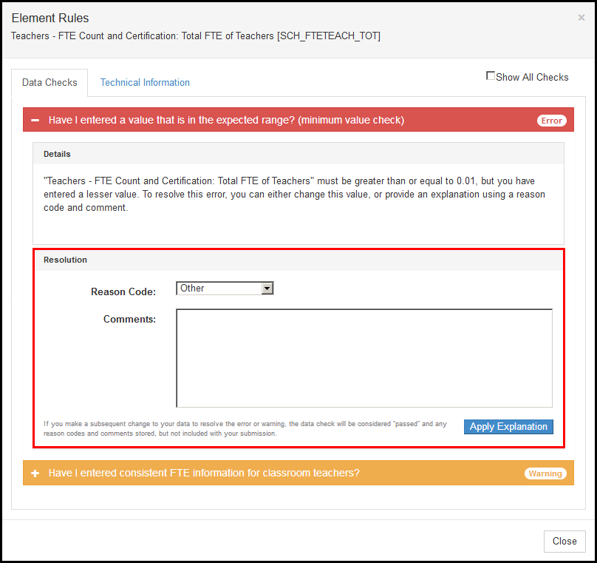
- Some errors will have Reason Code drop-down options for you to select. If you choose Other, you must enter an explanation Comment.

- Click Apply Explanation.

To use the School Form Submission:

- Click on School Form Submission
- Select the school you wish to work with
- Follow the exact same steps to complete this section

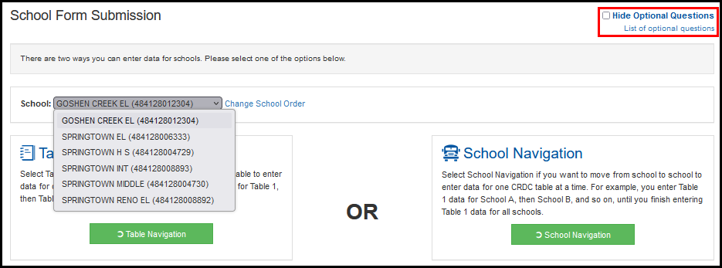

Reports

The purpose of the Reports section of the tool is to provide the user’s primary access to reporting functionality. The Reports screen supports the download of seven report types:

- Submission Review Report
- Data Feedback Reports
- LEA Submissions Download
- Error Resolution Report
- Submission Progress Report
- User Access Report
- Domino Effect of Changes Report

Certification
In order to proceed to final certification of an LEA’s data submission, all required data fields must be submitted for both the District Form and all related School Forms and no errors may exist for any data submitted that have not been either explained using a reason code and/or comment or overridden by the PSC.

In order to start the certification process, the user must first go to the Certification Dashboard using the Certification menu link provided in the menu at the top of every screen. Again, only those authorized to certify data for the LEA will have this item in their menus.
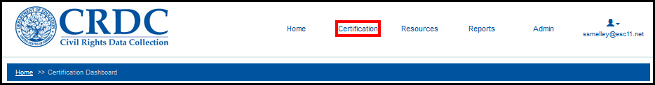

Pre-Certification Check Preview

This function allows the user to generate a comprehensive error and warning report for all data that need to be submitted prior to certification for the LEA.

- Click the Run Pre-Certification Check Preview button
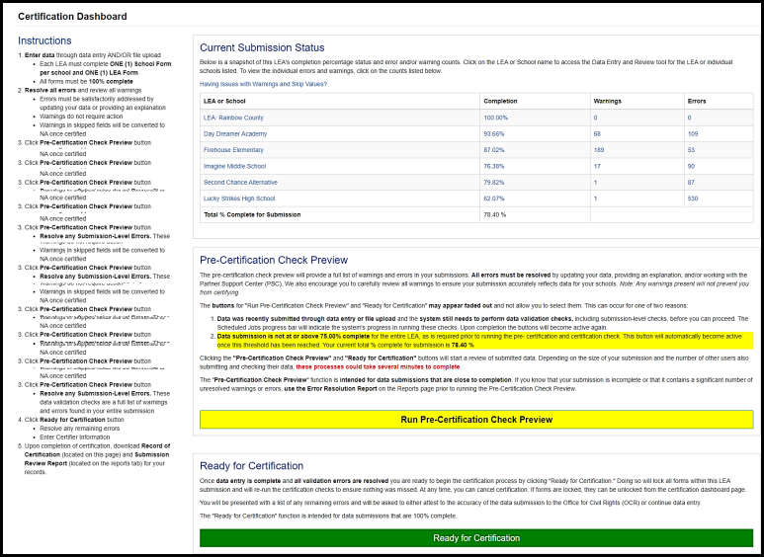
- Upon completion, the results of these checks are displayed in two tables. The first one details errors that can be resolved either by changing the data submitted, or by means of a reason code and/or comment explaining the validation check error listed in the first table.
- Scroll down, the second table is displayed for errors that require review from the Partner Support Center (PSC) if the submitted data underlying the validation check error are not going to be changed.

Certification

If there are no issues blocking certification, the system presents the (authorized) user with the form used to certify the data submission. Only the LEA superintendent, or another person designated by the LEA superintendent, is authorized to complete this form and fully certify the LEA’s CRDC submission.

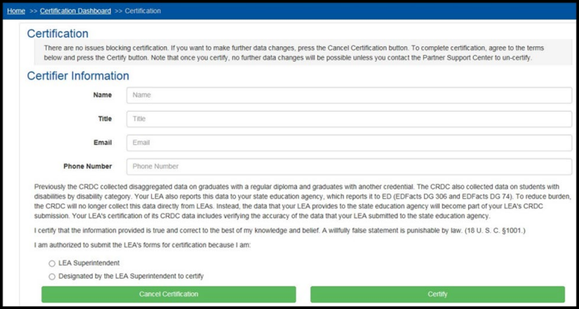
Potential Issues Preventing Certification – Any missing required data, or data triggering an error according to the validation checks, may prevent certification for the LEA until they are either corrected, explained using a reason code and/or comment, or overridden or exempted by the PSC or OCR.

Requesting Reversal of Certification by PSC – There may be circumstances in which an LEA decides that some of its data need to be revised or updated, even after certification. In these cases, the LEA must contact the PSC to request that the certification be reversed, and the forms unlocked to allow further editing by the LEA.

